**Inclass Programming Assignment - 2**

**Github Link:** <https://github.com/Viditha2277/DSA-5710/tree/main/Assignment%202>

**Description:**

* Using a python code to display the following star pattern using the for loop.

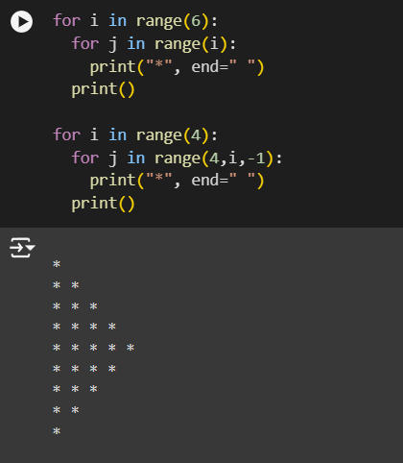

**Description:**

* Using looping to output the elements from a provided list present at odd indexes

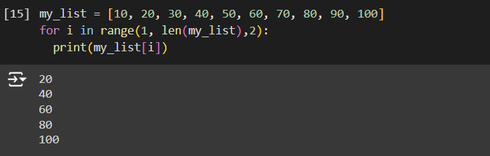

**Description:**

* Appending the type of elements from a given list

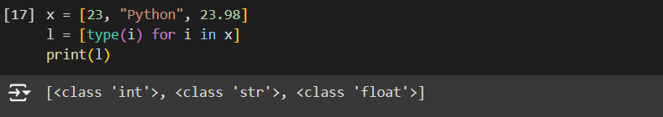

**Description:**

* Function that takes a list and returns a new list with unique items of the first list

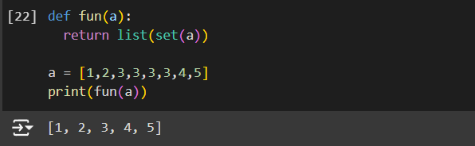

**Description:**

* Function that accepts a string and calculate the number of upper-case letters and lower-case letters.

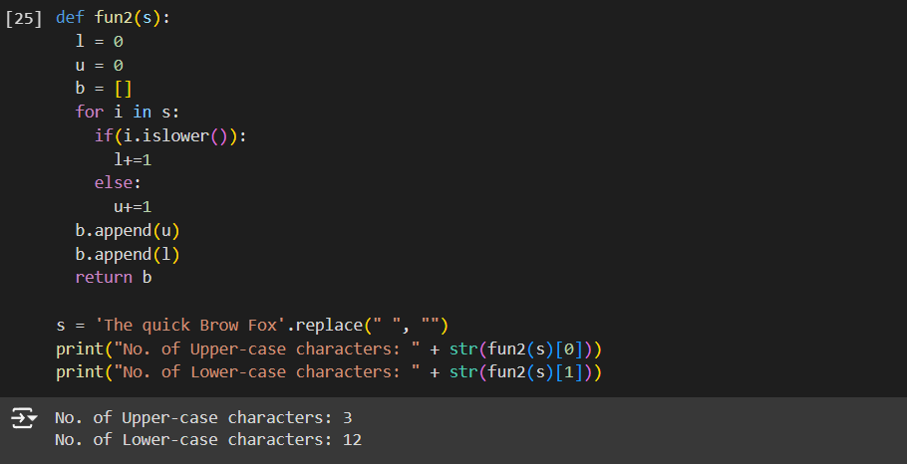

**Description:**

* Finding unique words that have been used in the sentence using the split methods and set to get the unique words.

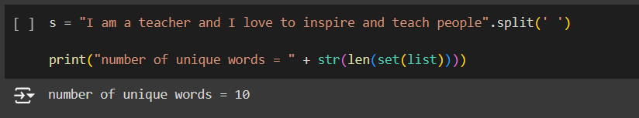

**Description:**

* Using a tab escape sequence to get the following lines.

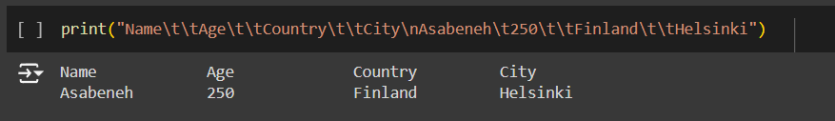

**Description:**

* Using the string formatting method to display the following output.

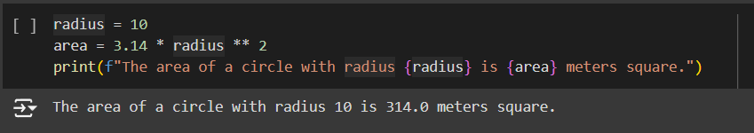

**Description:**

* Converting weights in lbs to kilograms in a separate list

